Board Programming guide:

# Setup:

If not already, the Arduino IDE needs to be installed, it can be found here:

<https://www.arduino.cc/en/software>

Once installed the Seeeduino Xiao board must be added to its list of known boards. To do this open the IDE, and select: **File -> Preferences**

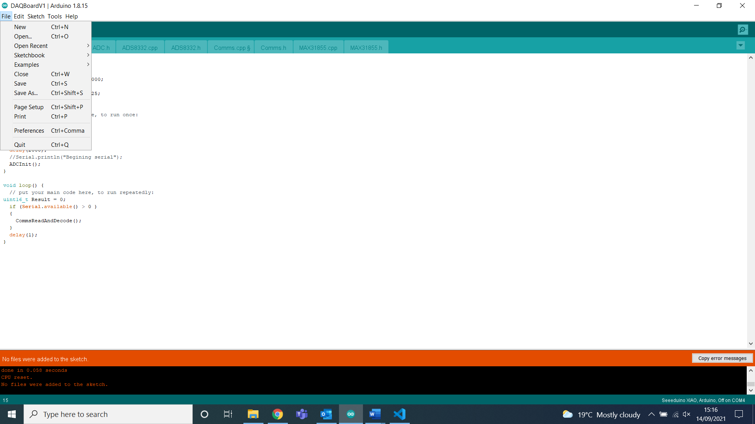

This will bring up a new window with settings on it. Near the bottom of the Settings tab (The new window should default to this tab when opened) there is a space to enter **Additional Board Manager URLs**. In this box enter:

<https://files.seeedstudio.com/arduino/package_seeeduino_boards_index.json>

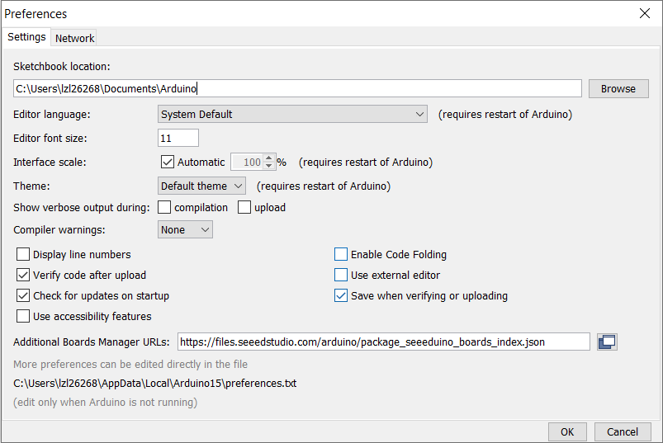

Click Ok on that window to save this. Next press: **Tools -> Board -> Board Manager** to open up another new window.

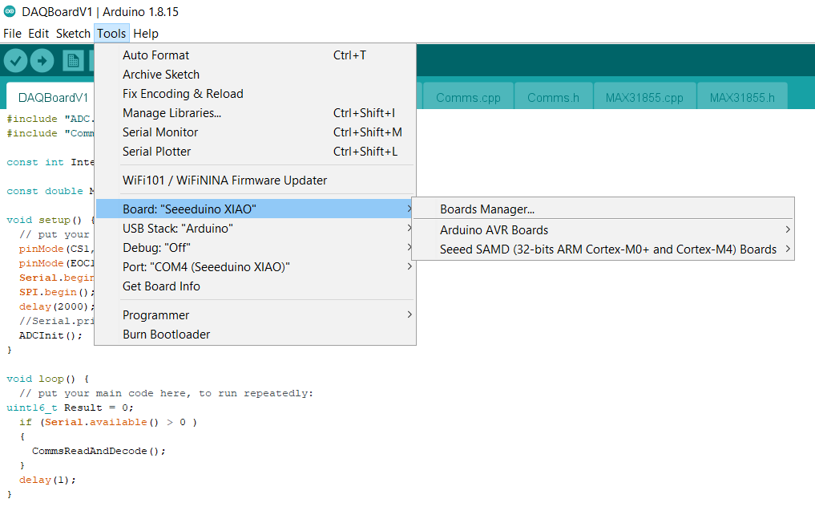

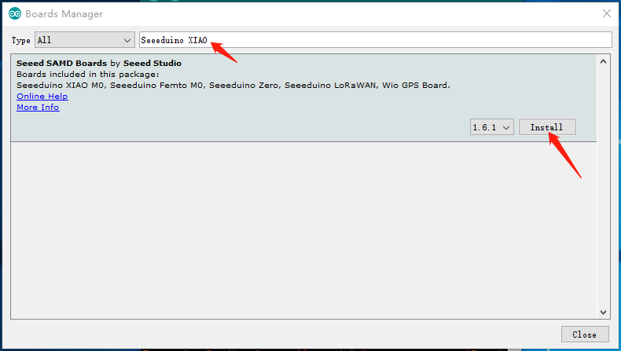In this new window type “Seeeduino Xiao” into the search box and install the “Seeed SAMD Boards” option.

Close this window after installation. Now go back to **Tools -> Board** and this time select the option for the seeeduino Xiao.

# Programming

Now make sure the board is connected to the pc via usb. In the **Tool -> Port** menu a COM port should be listed with the Seeeduino Xiao listed after the port number, make sure this is the one selected.

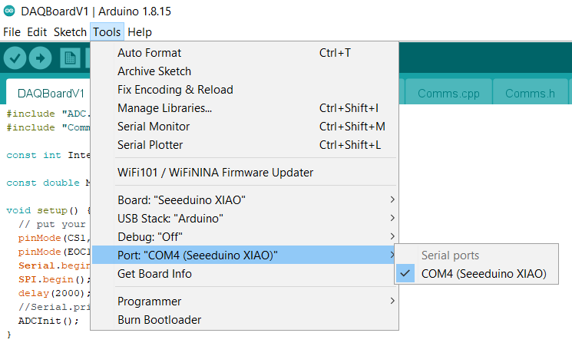Next load the file into the IDE by pressing: **File -> Open** and selecting the .ino file called DAQBoard. This should open the .ino file into the IDE along with the .cpp and .h files that should be in the same folder.

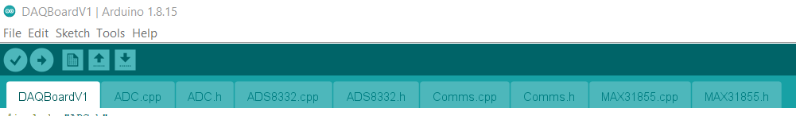Now press the Upload button just below the edit button in the top left of the IDE. This will cause the IDE to compile and verify the code and then upload it. The progress of this can be seen in the bottom right of the IDE:

Once done this message will show in the output box at the bottom of the IDE:

The board has now been programmed.

# Note:

The Setup procedure only has to be done once on the laptop/pc that you want to program the boards from. The programming section is repeated per board.